FY 2024 Graduate School of Sustainability Science,

Department of Agricultural Science/Department of Dryland Science and

The United Graduate School of Agricultural Sciences

**Student Recruitment Notice for “Poland Visiting Program”**

We recruit students for our short-term program in which participants join “Habitat Studies” offered at a research station of University of Warsaw, Poland. This program provides students with the ability to scientifically evaluate the natural environment from various aspects such as soil science, plant ecology, and ecosystem services through both lectures and practical field work. The program is open to those who wish to improve the field science skills and learn in the overseas research environment with the aim of becoming human resources who can take an active part in the global community.

1. **Outline and Objectives**

In this program, students will join “Habitat Studies” offered at the Faculty of Biology, University of Warsaw, in English. Students will acquire the ability to scientifically evaluate the natural environment from aspects such as soil science, plant ecology, and ecosystem services in wetlands, oak forests, alder forests, coniferous forests, semi-natural grasslands, and agricultural sites.

In lectures, students study the relationship between climatic and geographical factors, topography, moisture conditions, soil, and vegetation, and learn how the natural environment is formed and maintained. In the field, students practice the physical, chemical, and biological properties of geology and soils, and sampling is conducted for chemical analysis in the laboratory. Students observe soil invertebrates and fungi that are important in organic matter decomposition, material cycling, and soil formation, and learn about aquatic plants and plankton in small bodies of water and their ecosystem functions. Students will also analyze the relationship with the management of the study site and learn about environmental conservation in a practical manner. Finally, a summary presentation and discussion will be given. Through the above, we aim to improve students’ skills to:

1. understand and scientifically evaluate the ecosystem function of the target site in the field
2. identify important ecological factors affecting soil properties and vegetation
3. decipher the complex relationships among groups of organisms with differing functionality in natural and semi-natural ecosystems
4. use modern techniques in soil science and ecology in appropriate ways

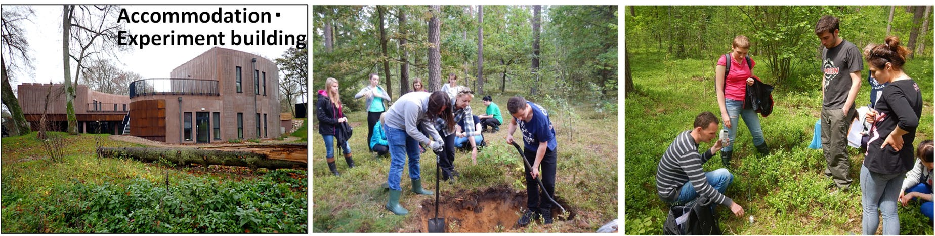

1. **Eligibility and Requirements**

Applicants must meet all the following conditions.

1. Those who are (1) Master's course students of Department of Dryland Science or the Department of Agricultural Science, Graduate School of Science for Sustainable Society, or (2) doctoral course students of the United Graduate School of Agricultural Sciences, Tottori University who is supervised by a faculty member participating in a research project of IPDRE
2. Those who are physically and mentally healthy and highly motivated.
3. Those who have the consent of their supervisor and parents/guardians to participate in this program.
4. Those who have a certain level of English proficiency.
5. Those who agree that their names, travel details, and reports will be made public on Tottori University’s website etc.
6. Those who have already taken the “Short-term Intensive Overseas Safety Seminar (e-learning)” or “Overseas Safety Management I” (2-credit courses given before 2023 is also available).
7. **Credit**

Upon completion of the program, students will receive a certificate from Warsaw University and can apply for using the acquired credits as TU’s credits.

1. **Period of dispatch**

August 30 (Friday) to September 16 (Monday), 2024

Note: Dates may be changed depending on flights.

1. **Number of students to be dispatched**

10 (tentative)

Note: Selection will be made for all applicants based on the submitted documents and interviews.

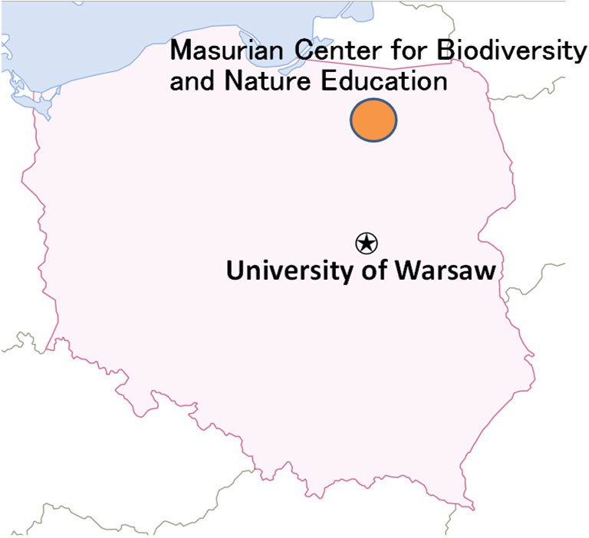

1. **Course fees (under consideration)**

Maximum 100,000 JPY

1. **Accompanying faculty member**

Prof. Takao Ishikawa (University of Warsaw)

Prof. Dai NAGAMASTU (Tottori University)

Prof. Daichi HAGA (Tottori University)

1. **Place**

Republic of Poland, Masurian Lakeland,

The Masurian Center for Biodiversity and Nature Education in Urwitałt

<http://mazury.biol.uw.edu.pl/english/>

1. **Teachers of the Habitat Studies course**

* Professor Małgorzata Suska-Malawska (MSM)

Expertised in: biogeochemistry, soils science and ecosystem , ecology

* Professor Iwona Jasser (IJ)

Expertised in: hydrobiology and ecology of microorganisms

* Dr. Monika Mętrak Ph.D. (MM)

Expertised in: biogeochemistry (organic matter composition and transformations) and ecosystem ecology

* Dr. Mteusz Wilk Ph.D. (MW)

Expertised in: mycology and soil biology

1. **Detailed Schedule**

Note: Contents might be changed.

|  |  |
| --- | --- |
| August 30 (Fri) | Departure from Tottori |
| August 31 (Sat) | Arrival in Warsaw, Stay in Warsaw |
| September 1 (Sun) | Move to The Masurian Center for Biodiversity and Nature Education in Urwitałt  http://mazury.biol.uw.edu.pl/english/ |
| September 2 (Mon) | **Introduction to the Habitat Studies Course**  1. Lecture: Landscape and geohistory of the Masurian Lakes Region  2. Field: Landscape and nature observation of the Masurian Lakes Region  3. Lecture: Formation and characteristics of peatlands  4. Lecture: History and culture of the Lake Masurian Region |
| September 3 (Tue) | **Regular classes**  1. Lecture: Soils of the Lake Masurian region and field methods in soil science  2. Field: Coniferous and marsh forests - soil profile description, vegetation survey, soil sampling  3. Laboratory: Processing of soil and sediment samples |
| September 4 (Wed) | **Regular classes**  1. Field: Oak-shade forest and alder-soil profile description, vegetation survey, soil sampling  2. Lecture: fungi - diversity and function, function-based survey methods  3. Laboratory: processing soil and sediment samples 4. lecture: soil invertebrates  4. Lecture: soil invertebrates - diversity and function, function-based methods |
| September 5 (Thu) | **Regular classes**  1. Field: All study sites - soil invertebrate and mycorrhizal sampling  2. Laboratory: Macrofauna sorting  3. Laboratory: Setting up the Zurgren apparatus  4. Laboratory: Soil chemical analysis - pH, EC, particle size analysis Part 1  5. Preparation of organic sediment samples |
| September 6 (Fri) | **Regular classes**  1. Laboratory: Identification of fungi  2. Laboratory: Soil chemical analysis - pH, EC, particle size analysis Part 2  3. Laboratory: Analysis of organic sediments |
| September 7 (Sat) | **Regular classes**  1. Laboratory: Soil chemical analysis - particle size analysis Part 3  2. Laboratory: Identification of fungi  3. Laboratory: Identification of soil invertebrates  4. Laboratory: Dry mass analysis of soil Part 1 |
| September 8 (Sun) | **Regular classes**  1. Lecture: Physical and chemical characteristics of soils  2. Lecture: Biodiversity of lake ecosystems and the role of small water bodies in agricultural landscapes  3. Field: Water sampling for chemical and algal analysis from small watersheds  4. Laboratory: Dry mass analysis of soil Part 2  5. Laboratory: Soil chemical analysis - particle size analysis Part 4 |
| September 9 (Mon) | **Regular classes**  1. Laboratory: Identification of algae and aquatic plants  2. Workshop: Watershed conservation  3. Data processing of survey sites |
| September 10 (Tue) | **Summary Preparation**  1. Data processing of survey sites assigned to each group |
| September 11 (Wed) | **Summary Preparation**  1. Prepare a presentation on the research sites assigned to each group assigned habitats |
| September 12 (Thu) | **Final Presentation**  1. Final presentation  2. Cleaning and packing |
| September 13 (Fri) | Departure from Urwitałt to Warsaw |
| September 14 (Sat) | Sightseeing around Warsaw |
| September 15 (Sun) | Departure from Warsaw |
| September 16 (Mon) | Arrival in Tottori via Narita *Arrival in Tottori may be on the 17th |

* Contents and dates may change due to flight schedule, coordination with overseas partner institutions, etc.
* In addition to the above dispatch period, there will be one day each for pre- and post-dispatch study.
* For the outdoor activities, it is recommended to bring student ID card, waterproof goods (raincoat, boots, etc.), insect repellent, sunscreen, basic medicines against colds, allergies, a vacuum bottle.
* Please be sure to bring a laptop.

1. **Application period and method:**

Recruitment period: From Monday, June 3 to 5:00PM Monday, June 17, 2024

Submission: Submit the following documents to the places of submission.

Application documents: (1) Application form (see attached)

1. Copy of passport
2. Valid proof of English proficiency (TOEIC or TOEFL score reports, EIKEN test results etc.)
   * Submission is desired, but not necessary.
3. **Schedule for the application and screening:**

Interview date Friday, June 21, 2024

*Interviews will be conducted for all applicants. If you are unable to make the scheduled interview date, please let us know in advance.

*Information on the interview location and time will be provided through your supervisor.

Screening method Contents of application document and result of interview will be taken

into account.

Result notice Wednesday, 26 June 2024

1. **Note**

Please note that the program might be cancelled due to the spread of the new coronavirus or other unforeseen circumstances.

1. **Place to submit application documents**

Administration office of International Platform for Dryland Research and Education

Address: 1390 Hamasaka, Tottori, 680-0001

Email: [ipd-zim@ml.adm.tottori-u.ac.jp](mailto:ipd-zim@ml.adm.tottori-u.ac.jp)

1. **Inquiry**

Prof. Dai NAGAMATSU, Faculty of Agriculture, Tottori University

Tel.: 0857- 31-5112

Email: daina@tottori-u.ac.jp

2024年度 鳥取大学大学院 「ポーランド派遣プログラム」申請書

FY 2023 Graduate School of Sustainability Science, Master’s program

Application for “Poland visiting program”

|  |  |
| --- | --- |
| 所属： |  |
| Affiliation: |  |
| 氏名(押印又は自筆)： | ※パスポートと同様の氏名を記載 |
| Name (One’s own writing or affix seal): | (as shown on passport) |
| 国籍： |  |
| Nationality: |  |
| 生年月日： |  |
| Date of birth: |  |
| 健康状態： |  |
| Health status: |  |
| 応募動機： |  |
| Reason for application: |  |

指導教員確認欄Supervisor’s confirmation

　上記のとおり応募することを確認しました。

I hereby give my consent for above stated student to apply for the “Overseas Practice Exercise.”

|  |  |  |
| --- | --- | --- |
| 日付 | 氏名 | 印 |
| Date | Name | Seal |